3-Tier-Deployment of Application integration with DataDog

1. Setup all configuration of Infrastructure Database, Backend and Frontend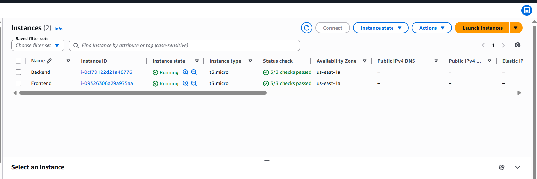

2.Next Go to Data Dog website https://www.datadoghq.com/ and Sign Up
Your new account or Login


3. Now to go Search Box type Install Agents and select Linux as per your OS. Now generated API_KEY and Copy Agent Installation CMD.

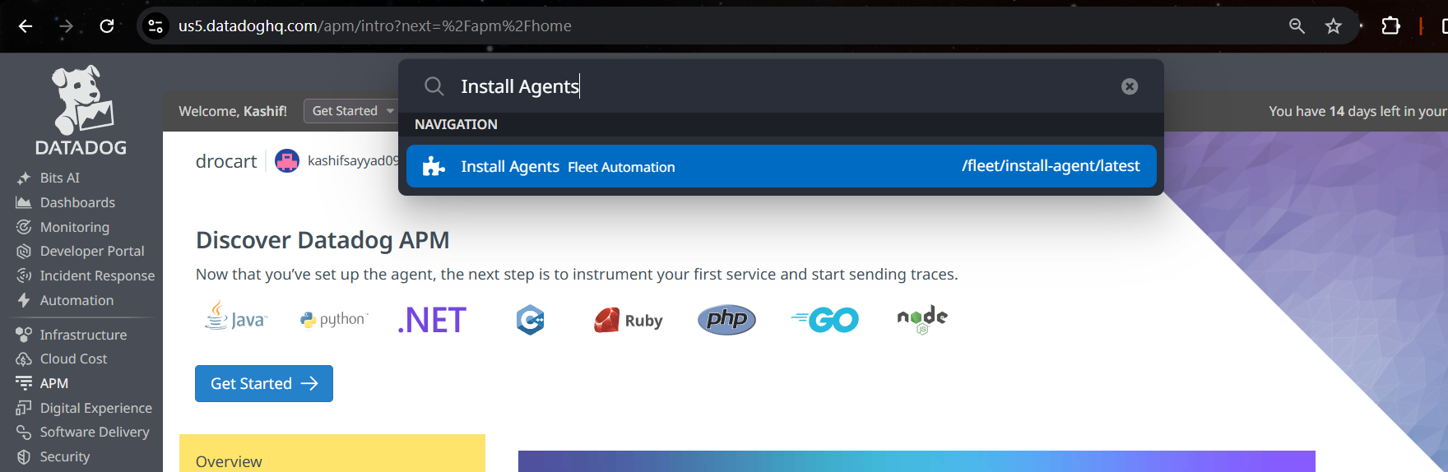

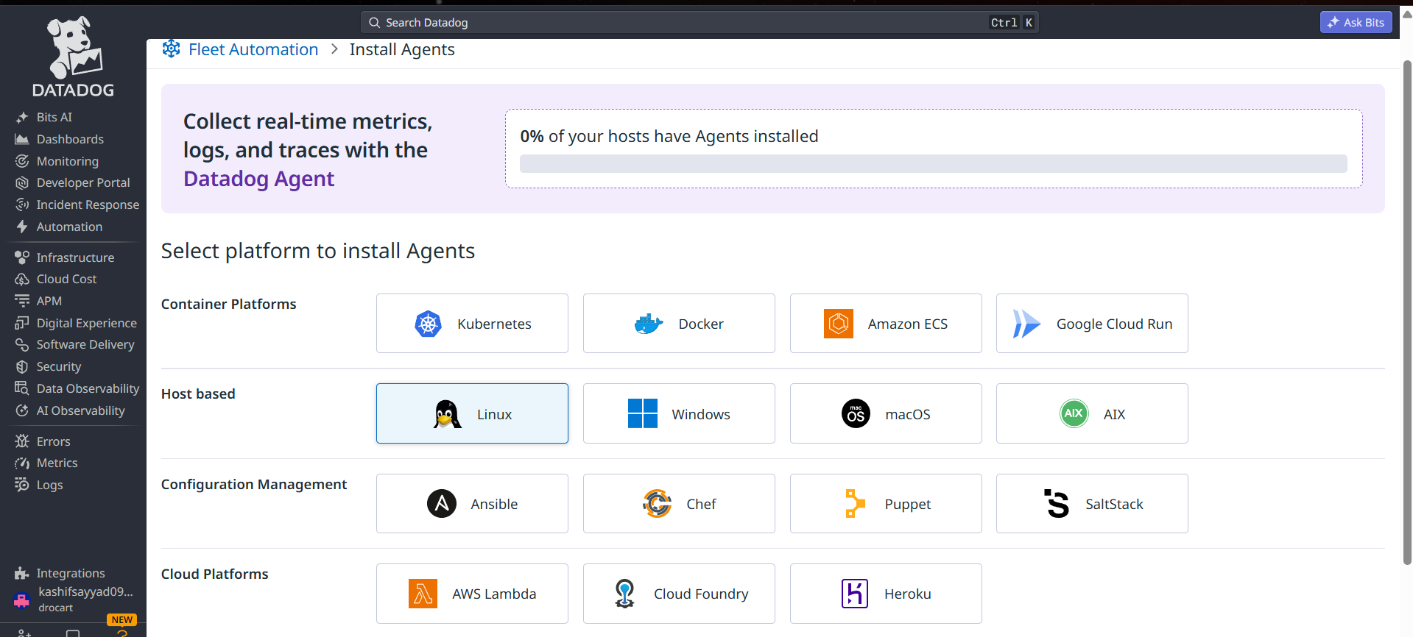

4. Select both Infrasture Monitoring and Application Performance for Logs and Metrics
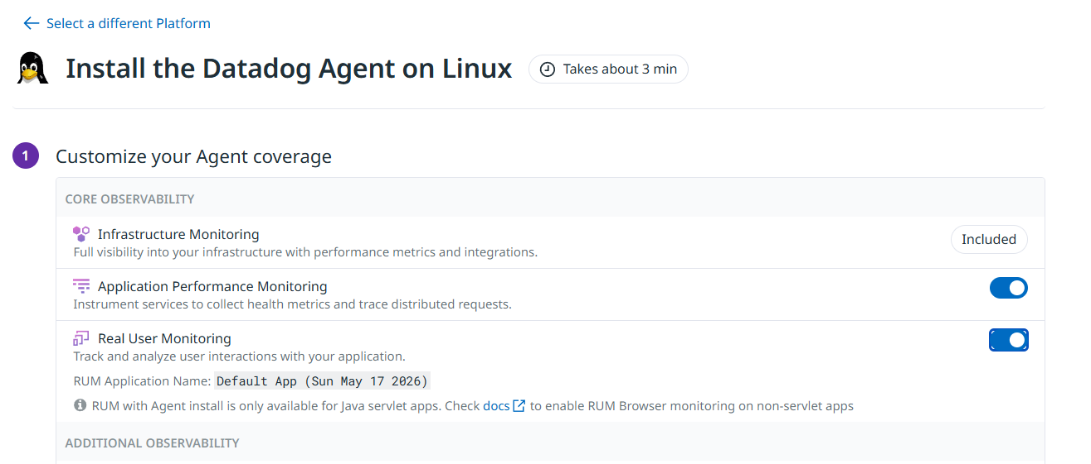
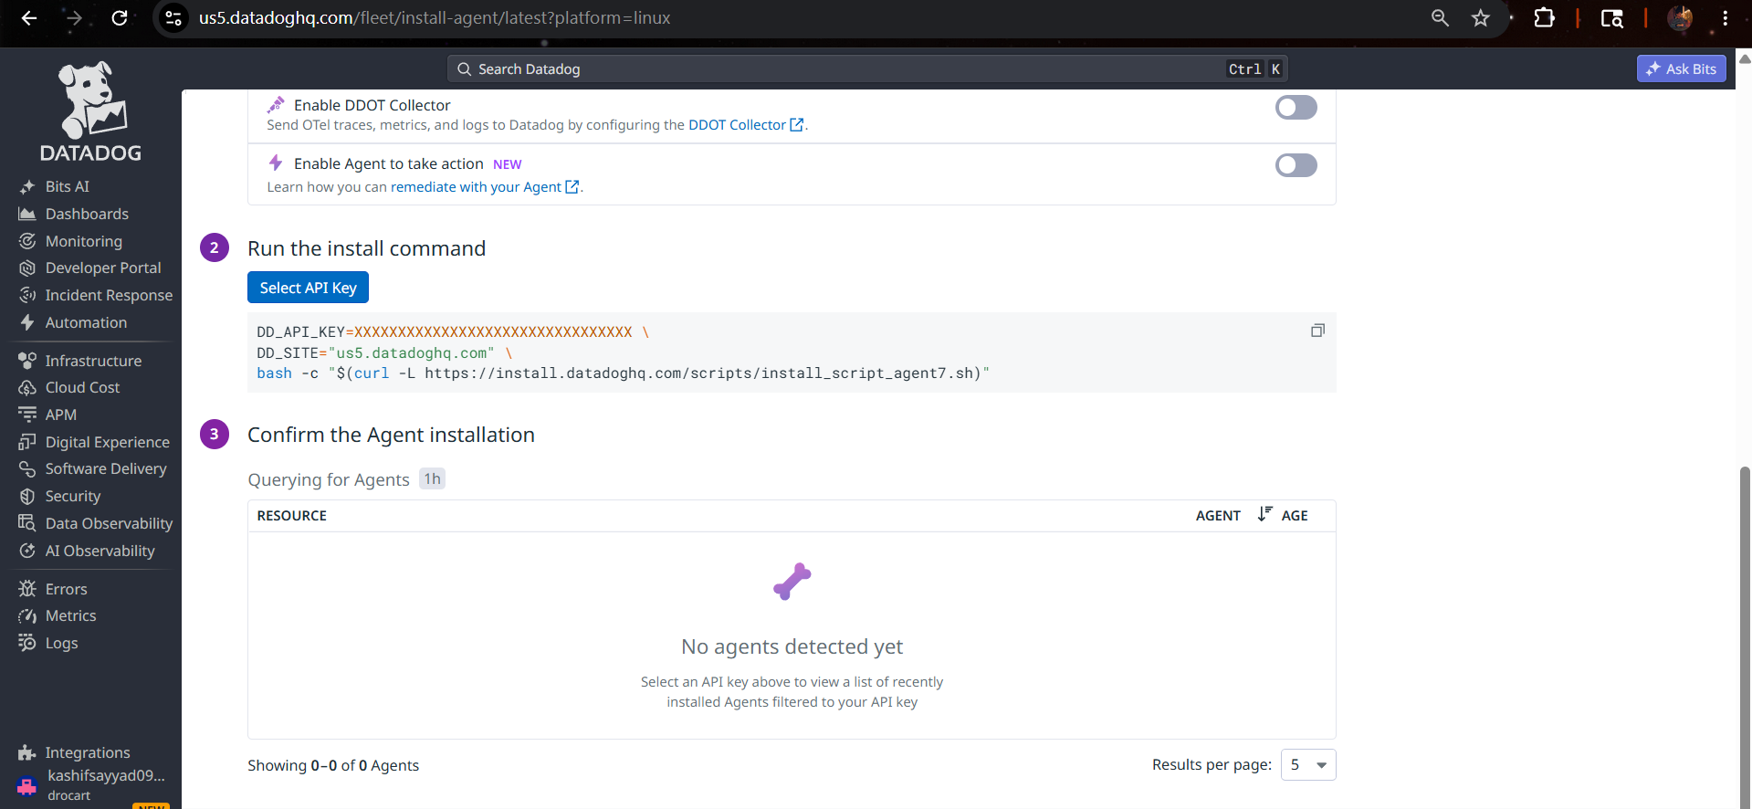

5.Now we have two Option:-
1.Create a Userdata script from Claude.ai by paste Agent CDM for AutoScaling
2.Direct paste Agent Installation CMD on Both servers frontend and Backend manually through SSM
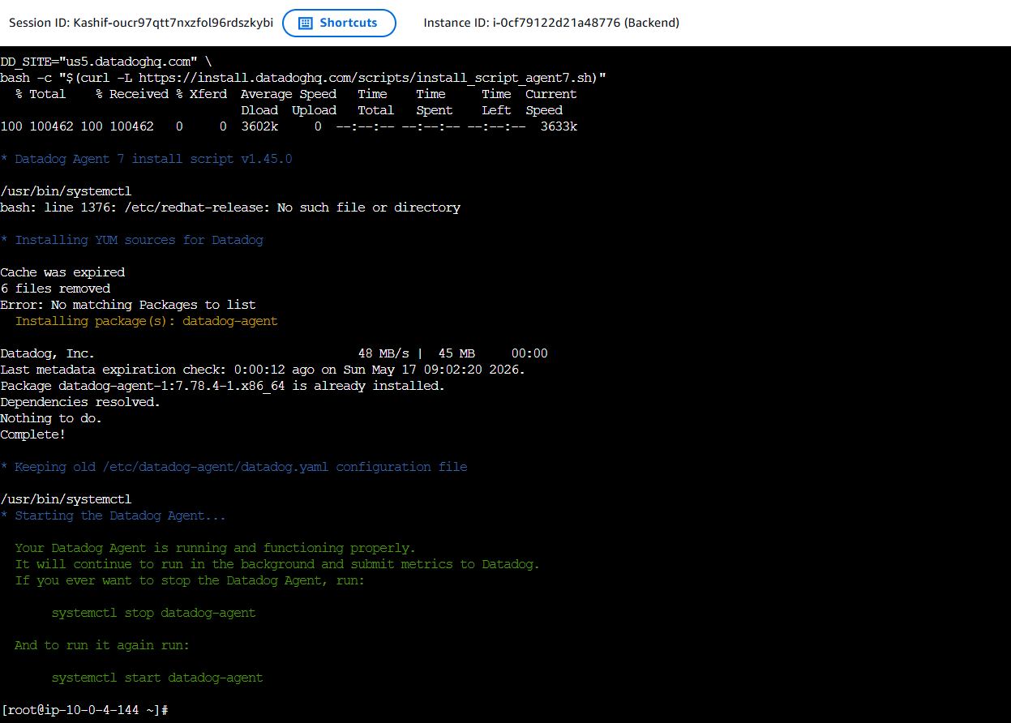

5.Now our Hosts Frontend and Backend successfully added
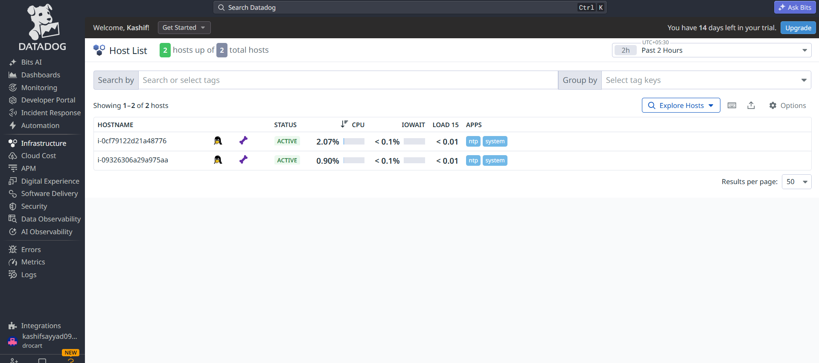

6.Now check Logs are visible or not. Logs

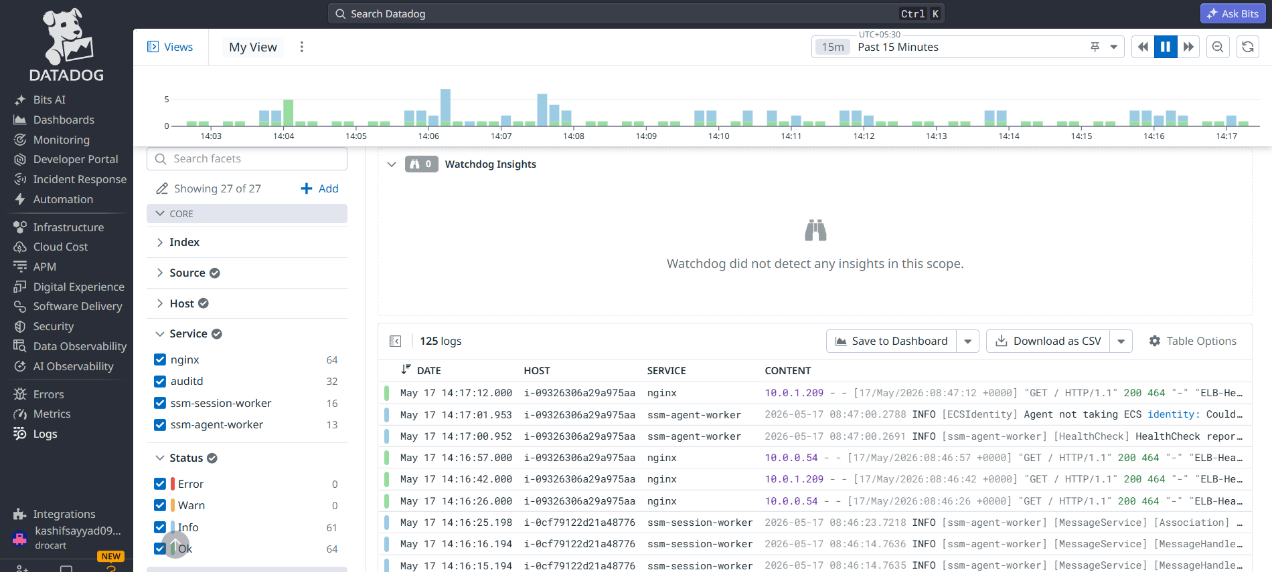

7.Final step Create Dashboard using Bits AI go to Dashboard New Dashboard Enter Prompt :- Create Entire Dashboard of All hosts Metrics.
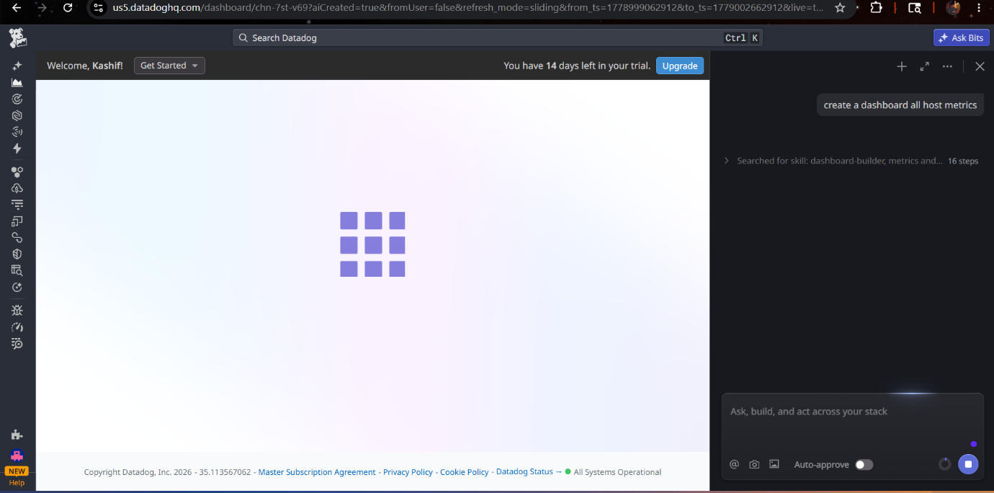

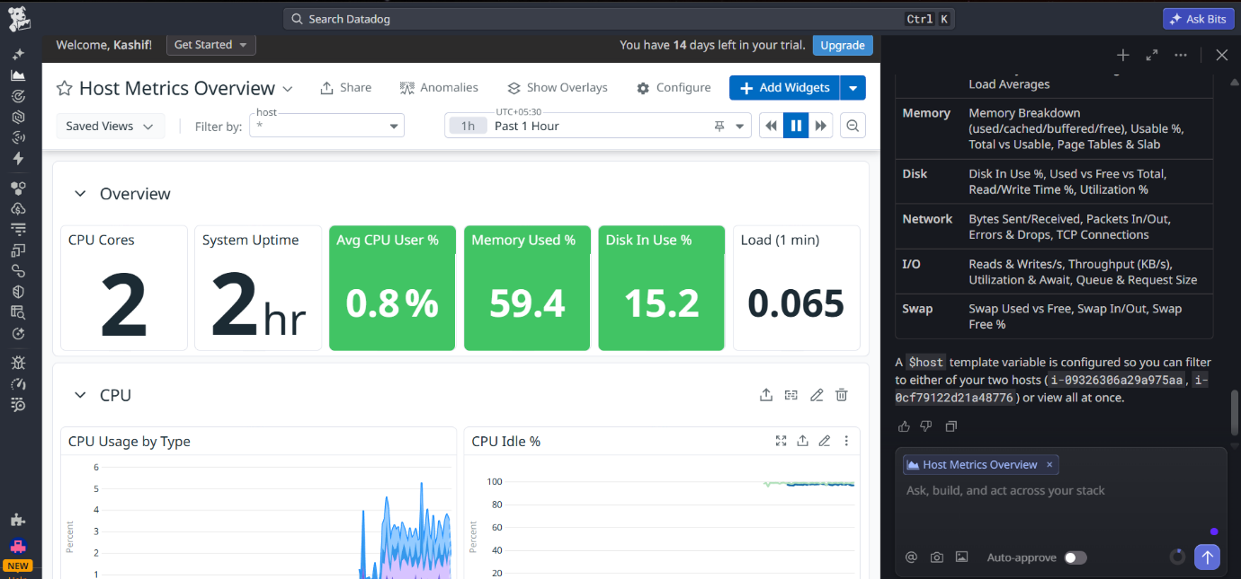
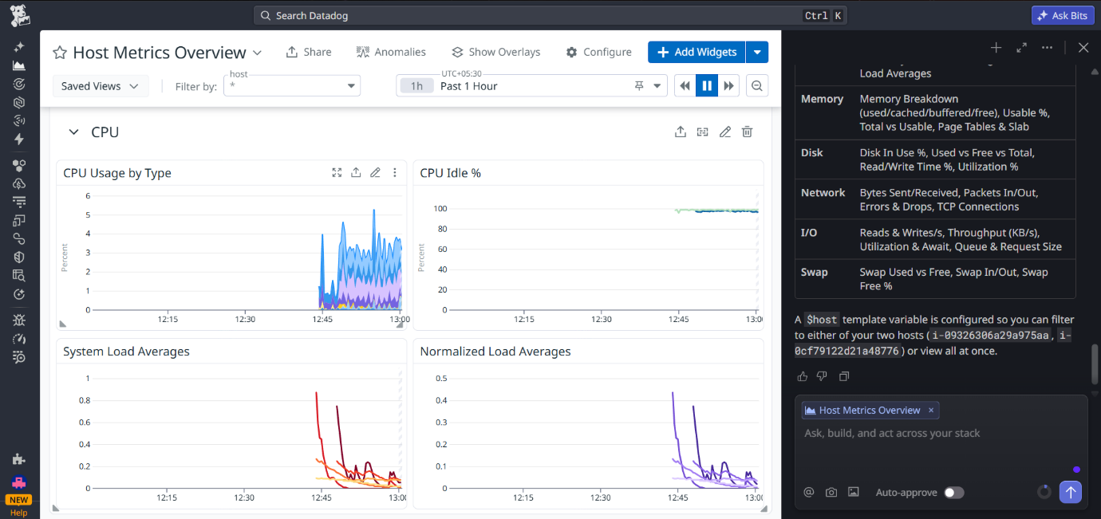
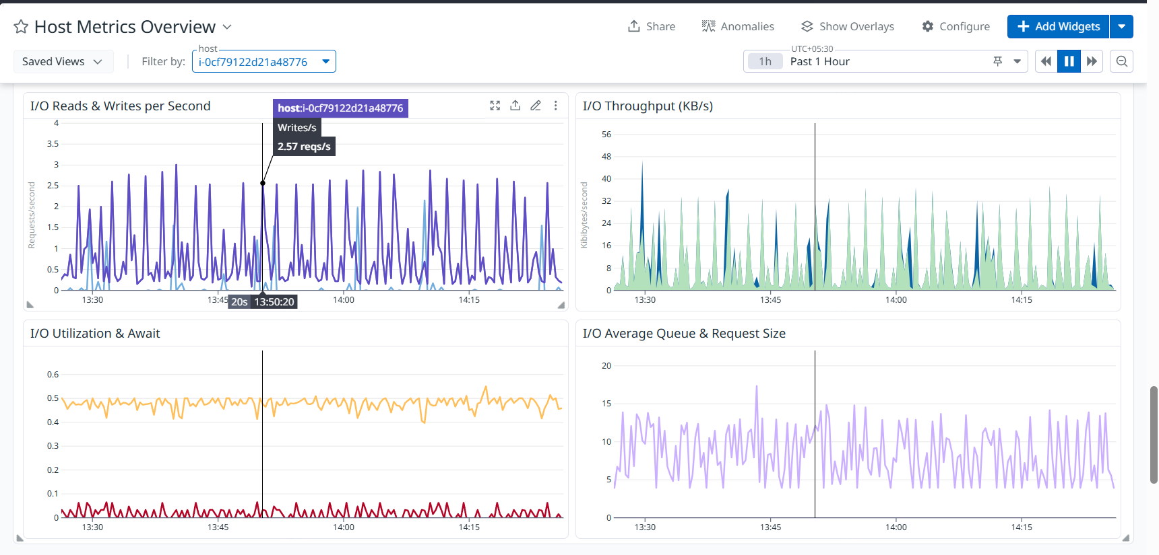

Created By Syed Kashif Ali

